Do Girls and Boys Experience Stress Differently?

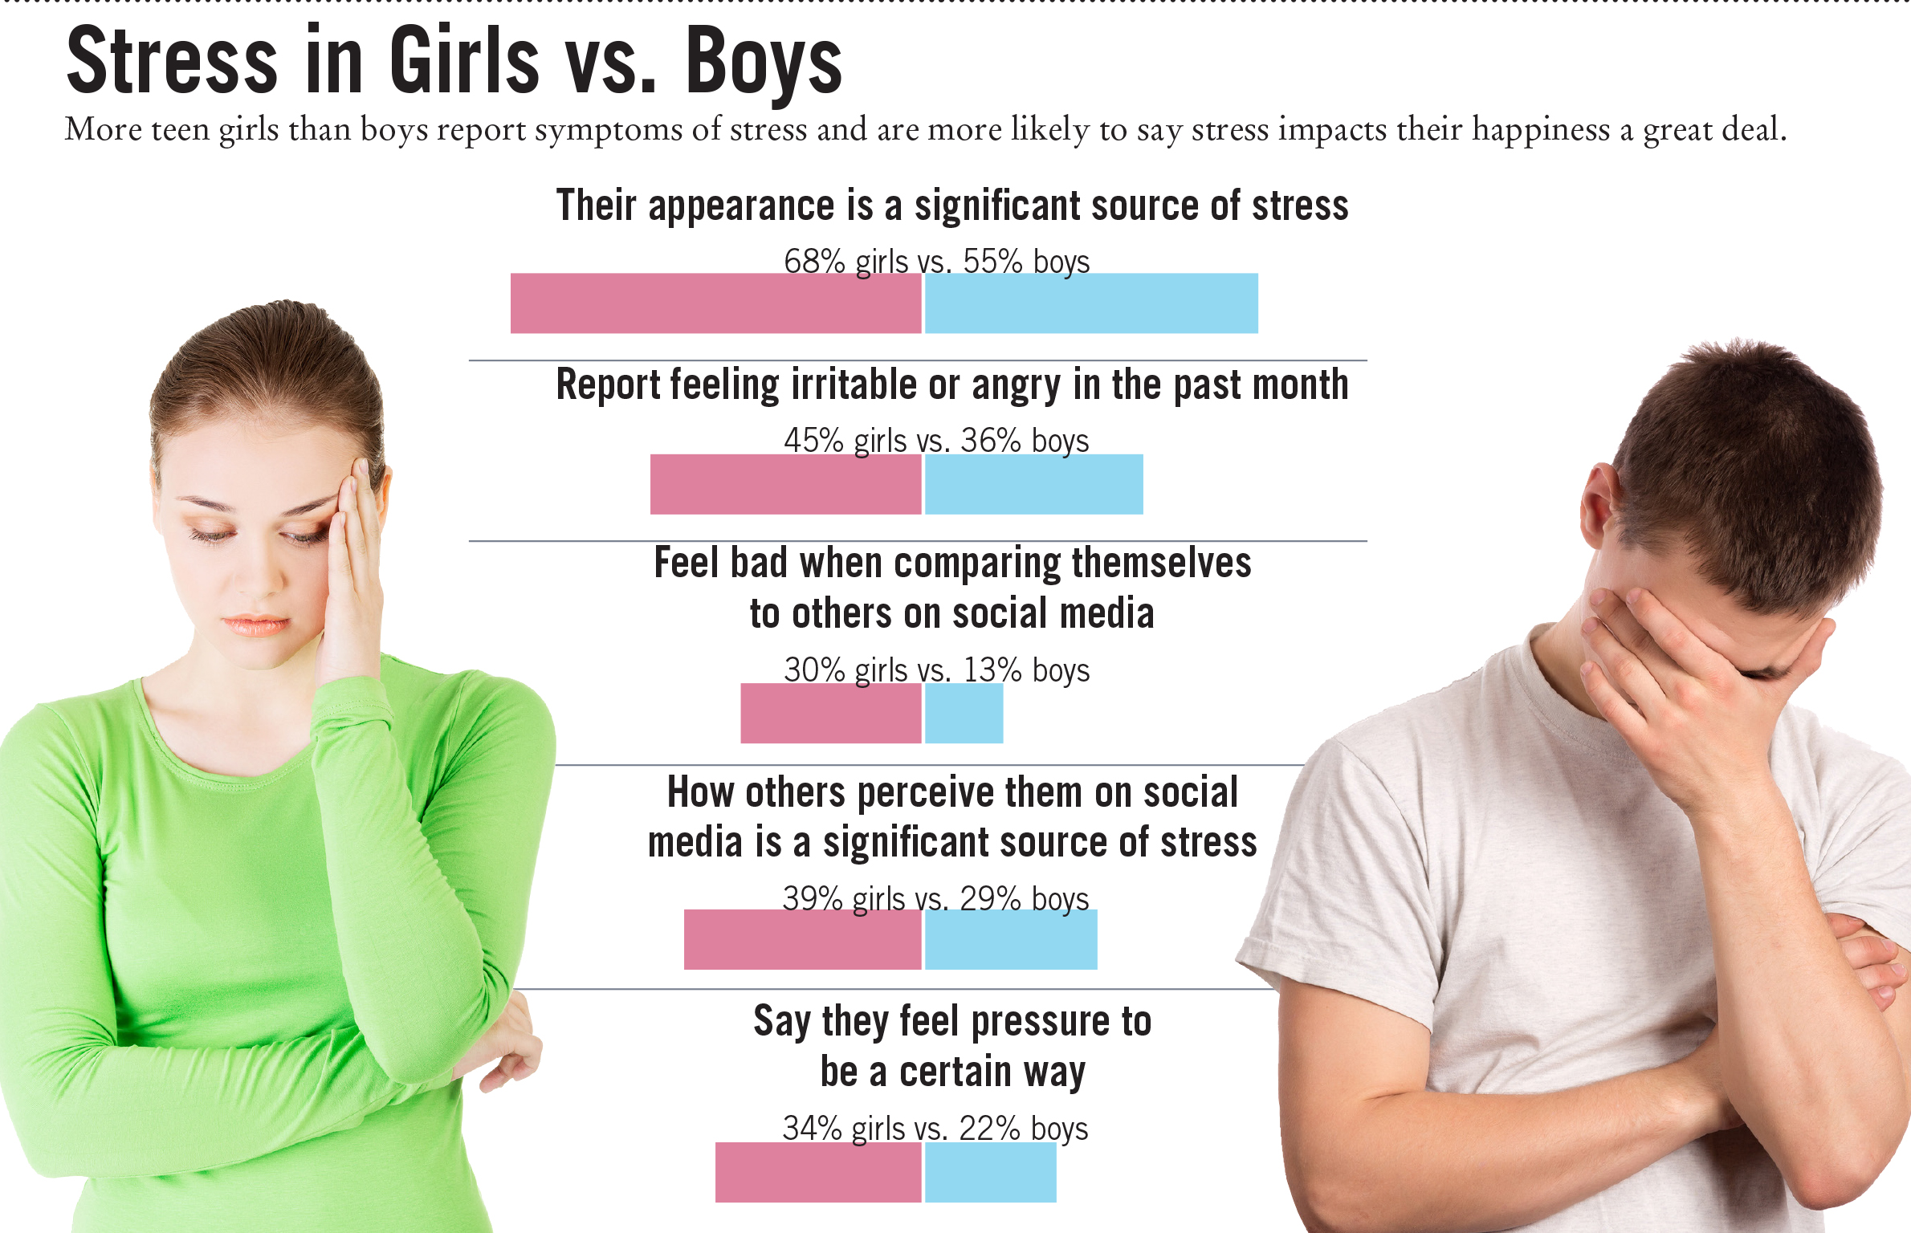

Talk with a partner or your table group:

- Have you experienced any of the above stressors?
- How did you handle it?

